TC-DISP-021
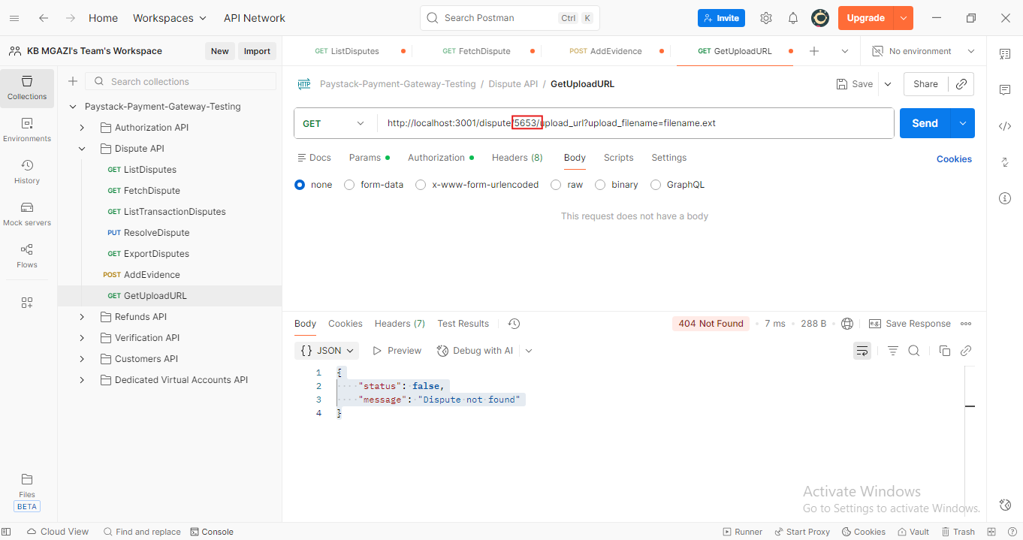
Response:
{
"status": false,
"message": "Dispute not found"
}

